Oceans: How Do They Affect Weather and Climate?
Adapted from Milton Kazmeyer, Henri Bauholz, and John Brennan, Sciencing 17-18
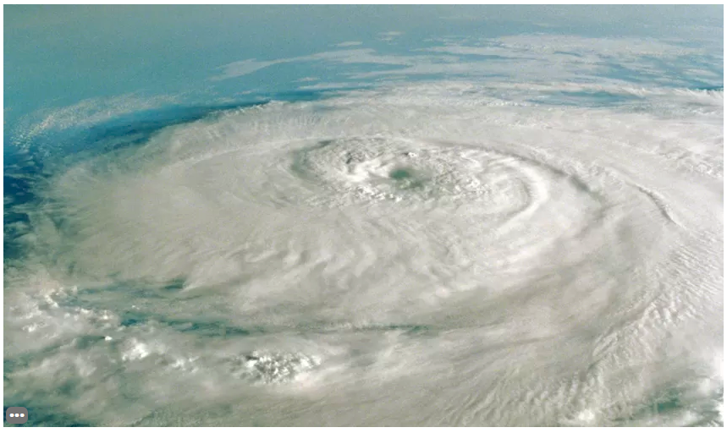
Seattle, Washington and Sioux Falls, South Dakota are found at similar latitudes. However, winters in Sioux Falls are much colder. This is because Seattle lies on the Pacific Ocean. The temperature in coastal regions does not vary to great extremes.
Land masses near oceans change temperature slower than land masses farther away. Oceans absorb heat from the sun during the summer, then release the heat during the winter. Ocean currents also transport heat from the equator towards the poles. When air passes over the warm ocean, its temperature increases. This warm air leads to milder temperature swings nearby.
The climate of coastal regions also tends to be wetter. Air that travels across oceans often picks up moisture before reaching shore. How do you think precipitation compares in Seattle and Sioux Falls most winters?

