Lakes: How Do They Affect Weather and Climate?
Adapted from Milton Kazmeyer, Henri Bauholz, and John Brennan, Sciencing 17-18

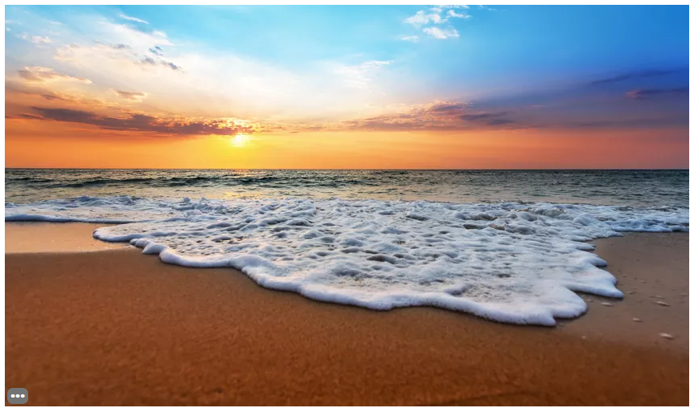

Why does the Lake Ontario region get so much snow each year? The Earth’s weather patterns are based on a number of different factors. Lakes can affect both short-term weather and long-term climate.
Large bodies of water like the Great Lakes increase precipitation nearby. In the winter, cold wind blows across the lakes and picks up moisture. This then falls over the far shores as lake effect snow.
Lakes also impact the temperature of an area. For example, the Great Lakes affect the temperature of air that travels across them, resulting in cooler summers and warmer winters. This moderates the climate, causing changes in temperature to be less extreme.

